User Manual
STEP 1 — Installation:
Visual Studio 2022 : https://visualstudio.microsoft.com/downloads/
- Choose: .NET Desktop Development
SQL Server Express : https://learn.microsoft.com/en-us/ssms/install/install
- Database engine
SSMS (SQL Server Management Studio): https://learn.microsoft.com/en-us/ssms/install/install
STEP 2 — In Visual Studio, Open Project [Windows Forms App]
- Language: C#
- Framework: .NET (latest or 6/7/8)
STEP 3 — Build UI
- Open the Form Designer
- Open Toolbox
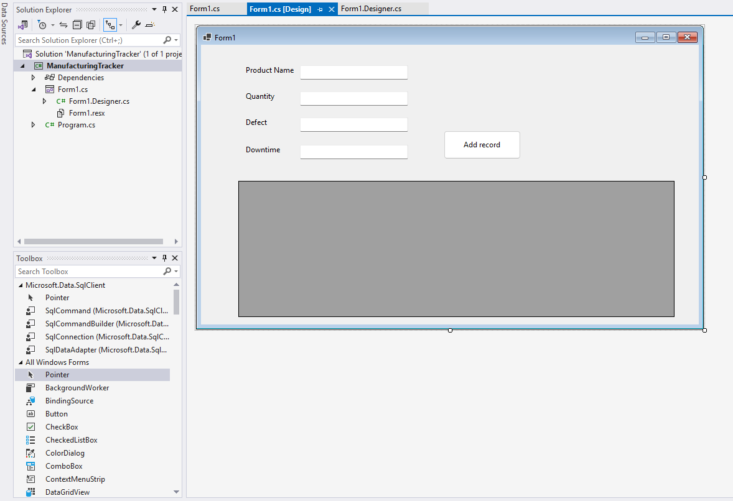
- Rename controls
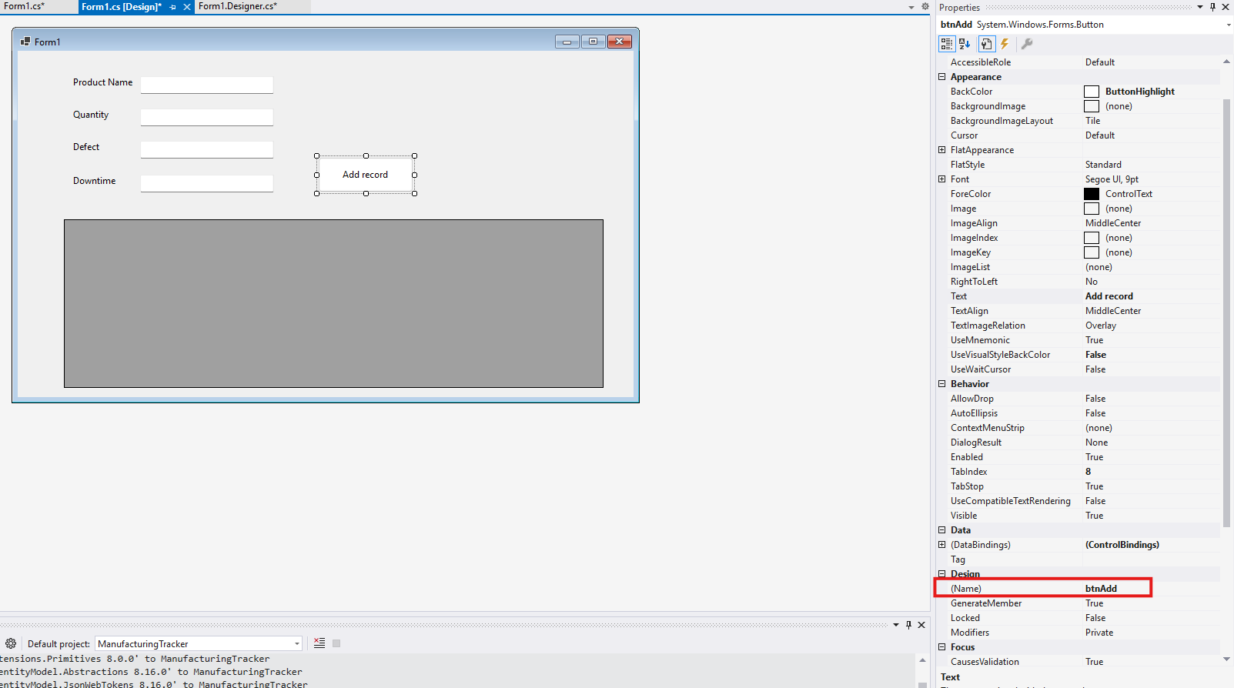
Step 6 — Create the Database in SSMS
CREATE TABLE Production (
Id INT IDENTITY(1,1) PRIMARY KEY,
ProductName NVARCHAR(100),
Quantity INT,
Defect INT,
DowntimeMinutes INT,
CreatedAt DATETIME DEFAULT GETDATE()
);

Step 7: Install SQL Package in Visual Studio
Tools → NuGet Package Manager → Package Manager Console
Run: Install-Package Microsoft.Data.SqlClient
Step8: Right-click your project → Add → Class
Name: DatabaseHelper.cs
using System;
using Microsoft.Data.SqlClient;

namespace ManufacturingTracker
{
public class DatabaseHelper
{
private string connectionString = "Server=localhost\\SQLEXPRESS;Database=ManufacturingDB;Trusted_Connection=True;TrustServerCertificate=True;";

public void InsertProduction(string product, int qty, int defect, int downtime)
{
using SqlConnection conn = new SqlConnection(connectionString);

conn.Open();

string query = @"
INSERT INTO Production
(
ProductName,
Quantity,
Defect,
DowntimeMinutes
)
VALUES
(
@product,
@qty,
@defect,
@downtime
);";

SqlCommand cmd = new SqlCommand(query, conn);
cmd.Parameters.AddWithValue("@product", product);
cmd.Parameters.AddWithValue("@qty", qty);
cmd.Parameters.AddWithValue("@defect", defect);
cmd.Parameters.AddWithValue("@downtime", downtime);

cmd.ExecuteNonQuery();
}
}
}

Form1.cs

SQL Note:
SQLServer: localhost\SQLEXPRESS
DROP TABLE if database current in use | USE master;  GO  ALTER DATABASE ManufacturingDB  SET SINGLE_USER  WITH ROLLBACK IMMEDIATE;  GO  DROP DATABASE ManufacturingDB;  GO
DROP DATABASE | USE master;  GO  DROP DATABASE ManufacturingDB;
CREATE DATABASE | CREATE DATABASE ManufacturingDB;  GO
CREATE TABLE | USE ManufacturingDB;  GO  CREATE TABLE Production  (  Id INT IDENTITY(1,1) PRIMARY KEY,  ProductName NVARCHAR(100) NOT NULL,  Quantity INT NOT NULL,  Defect INT NOT NULL,  DowntimeMinutes INT NOT NULL,  CreatedAt DATETIME DEFAULT GETDATE()  );  GO
Verify DATA | USE ManufacturingDB;  GO  SELECT *  FROM Production;
Add a new column for updated date | USE ManufacturingDB;  GO  ALTER TABLE Production  ADD UpdatedAt DATETIME NULL;

Select Row → Populate Textboxes
When user click the row, it will appear into textboxes
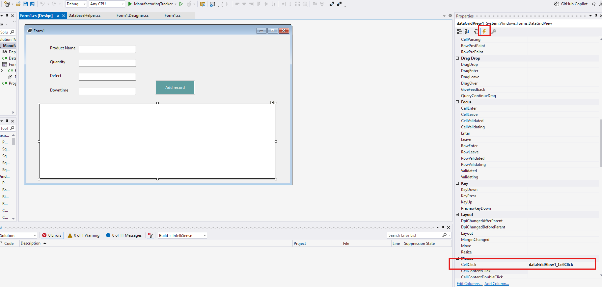
Form1.cs
private void dataGridView1_CellClick(object sender, DataGridViewCellEventArgs e)
{
if (e.RowIndex >= 0)
{
DataGridViewRow row =
dataGridView1.Rows[e.RowIndex];

txtProduct.Text =
row.Cells["ProductName"].Value?.ToString();

txtQuantity.Text =
row.Cells["Quantity"].Value?.ToString();

txtDefect.Text =
row.Cells["Defect"].Value?.ToString();

txtDowntime.Text =
row.Cells["DowntimeMinutes"].Value?.ToString();
}
}

UPDATE RECORD
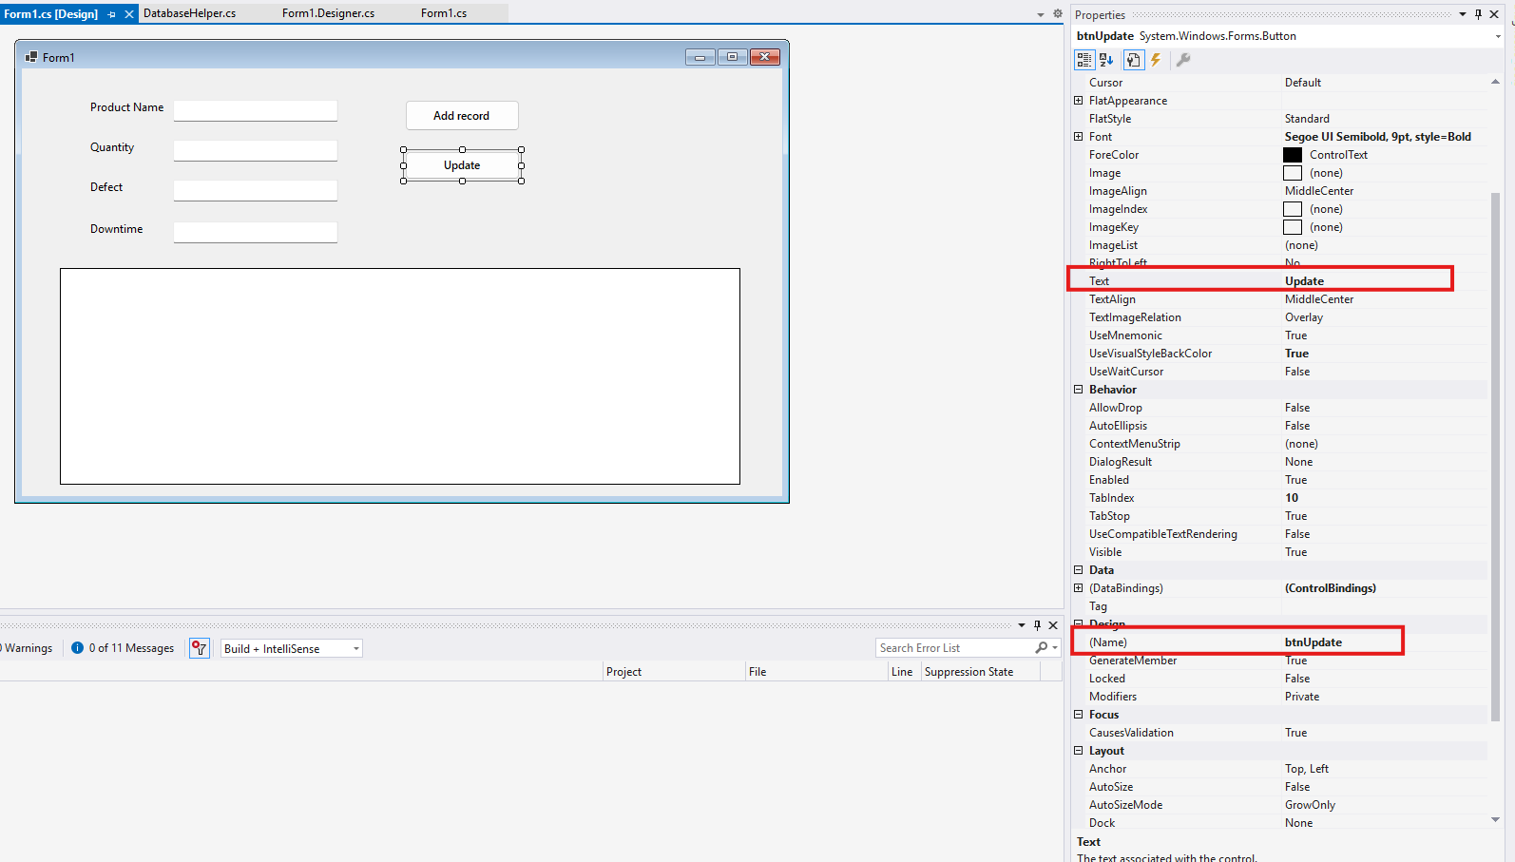

DELETE

SEARCH
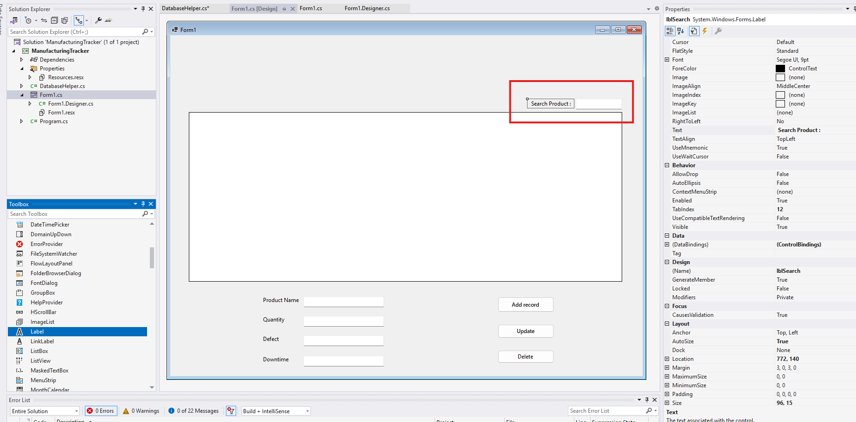
Label
Name: lblSearch
Text: Search Product
TextBox
Name: txtSearch
Create Search Event
In Designer:
- Click txtSearch
- Press F4
- Click ⚡ Events
- Double-click: TextChanged

EXPORT
Step 1: Install EPPlus
In Visual Studio:
Tools
→ NuGet Package Manager
→ Manage NuGet Packages for Solution
EPPlus
